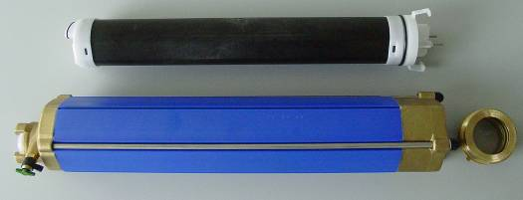
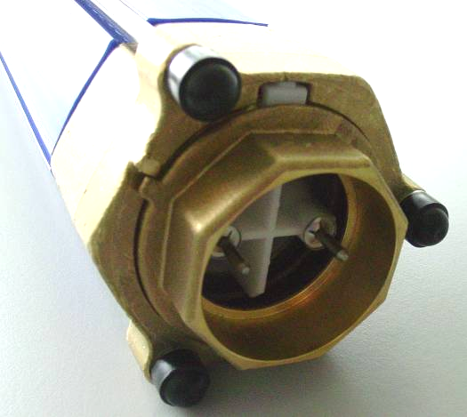
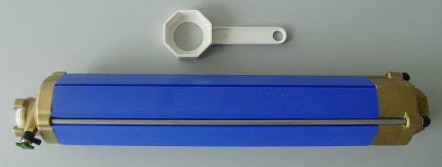
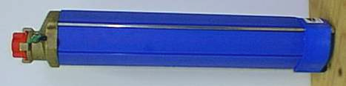
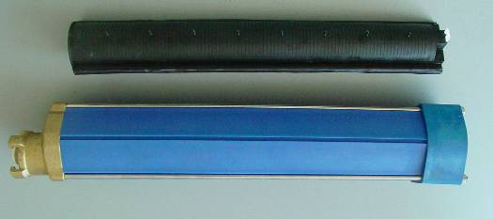
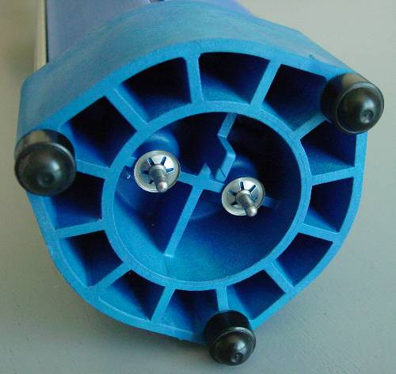
1
2
3
Difference between
AQA-total cartridge old / new
(since cartridge Nr. 236000)

Modifications:

- The plastic floor flange changed into press-brass flange, cartridge will be 5 mm longer.

- Sealing outwards through 2 o-ring gaskets (flange and device). Refill will be replaced though a complete device.

- The change of the device will be carried out on the lower surface (brass-flange). The whole cartridge don´t have be changed (see enclosure: change the device)

OLD
NEW
OLD
NEW
OLD
NEW
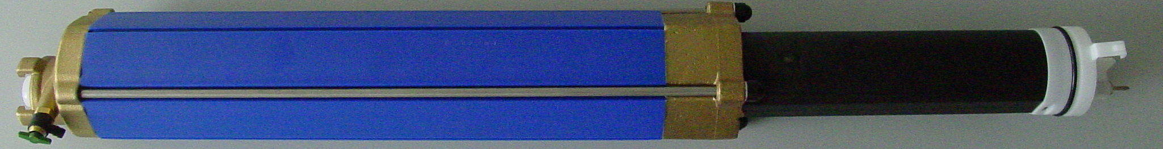
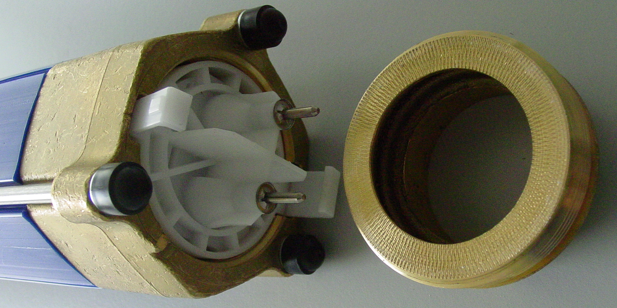
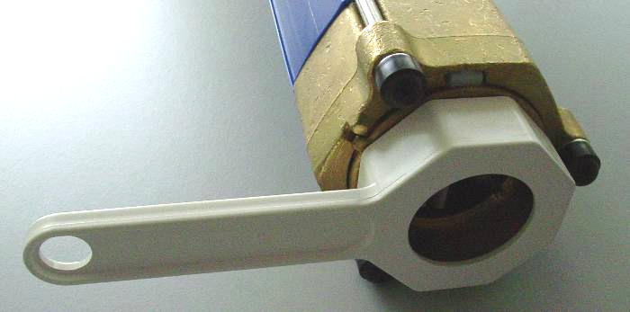
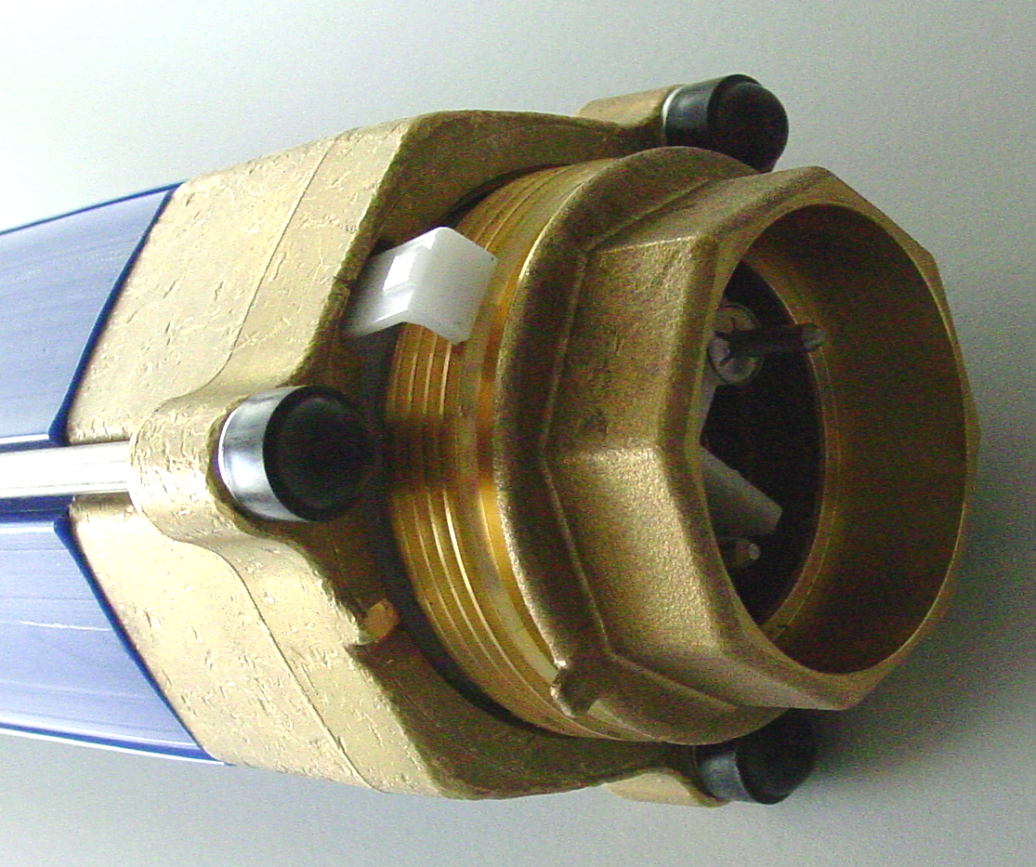
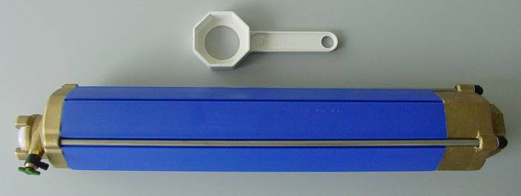
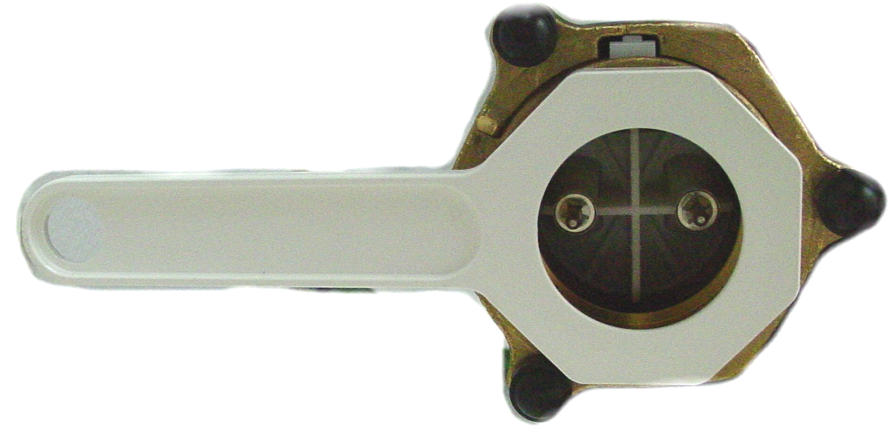
Change the device by
AQA-total cartridge new
(since cartridge Nr. 236000)
A. Dismounting of used devices

- Remove and deplete the cartridge from AQA-total.

- Demount the cup nut of the brass-flange with the key which will be delivered with the device.

- Move the key clockwise.

- By dismantling of the cup nut the device will be removed too.

- Loose the cup nut from the brass-flange.

- Remove the device from the cartridge.
OPEN
1
2
3
4
6
5
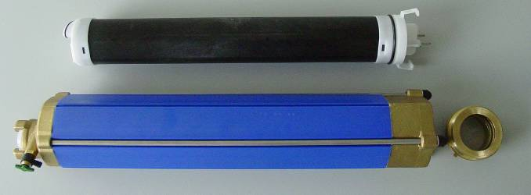
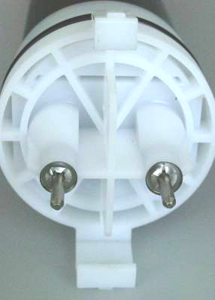
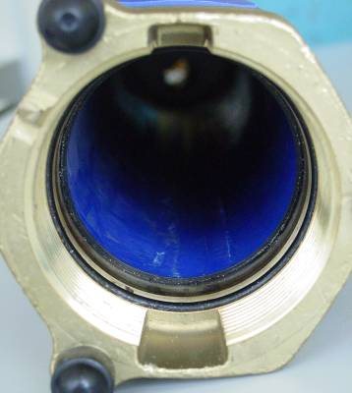
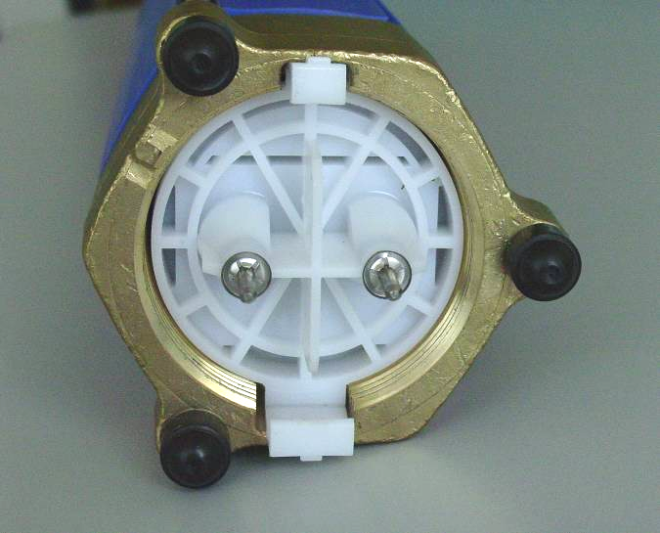
Change the device by
AQA-total cartridge new
(since cartridge Nr. 236000)

B. Installation
(mounting of the new device)

- To unpack the new device.

- Watch the mounting direction (devices can be mounted just in one direction):

2 a. At the flange there are 2 cuts
(recesses) with different
broadness, 180° displaced

2 b. The broadness of the cut have
to comply with the mounting
link.

- Install device into the cartridge.
1
2a
2b
3
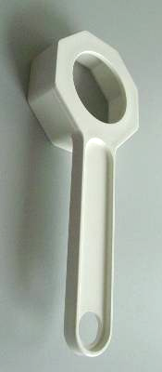
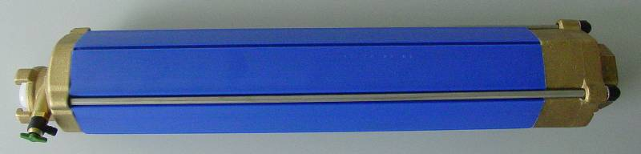
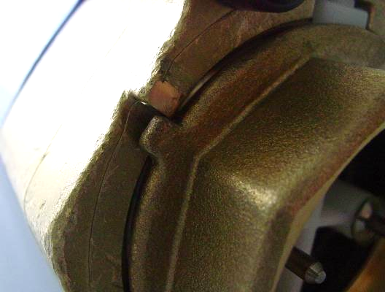
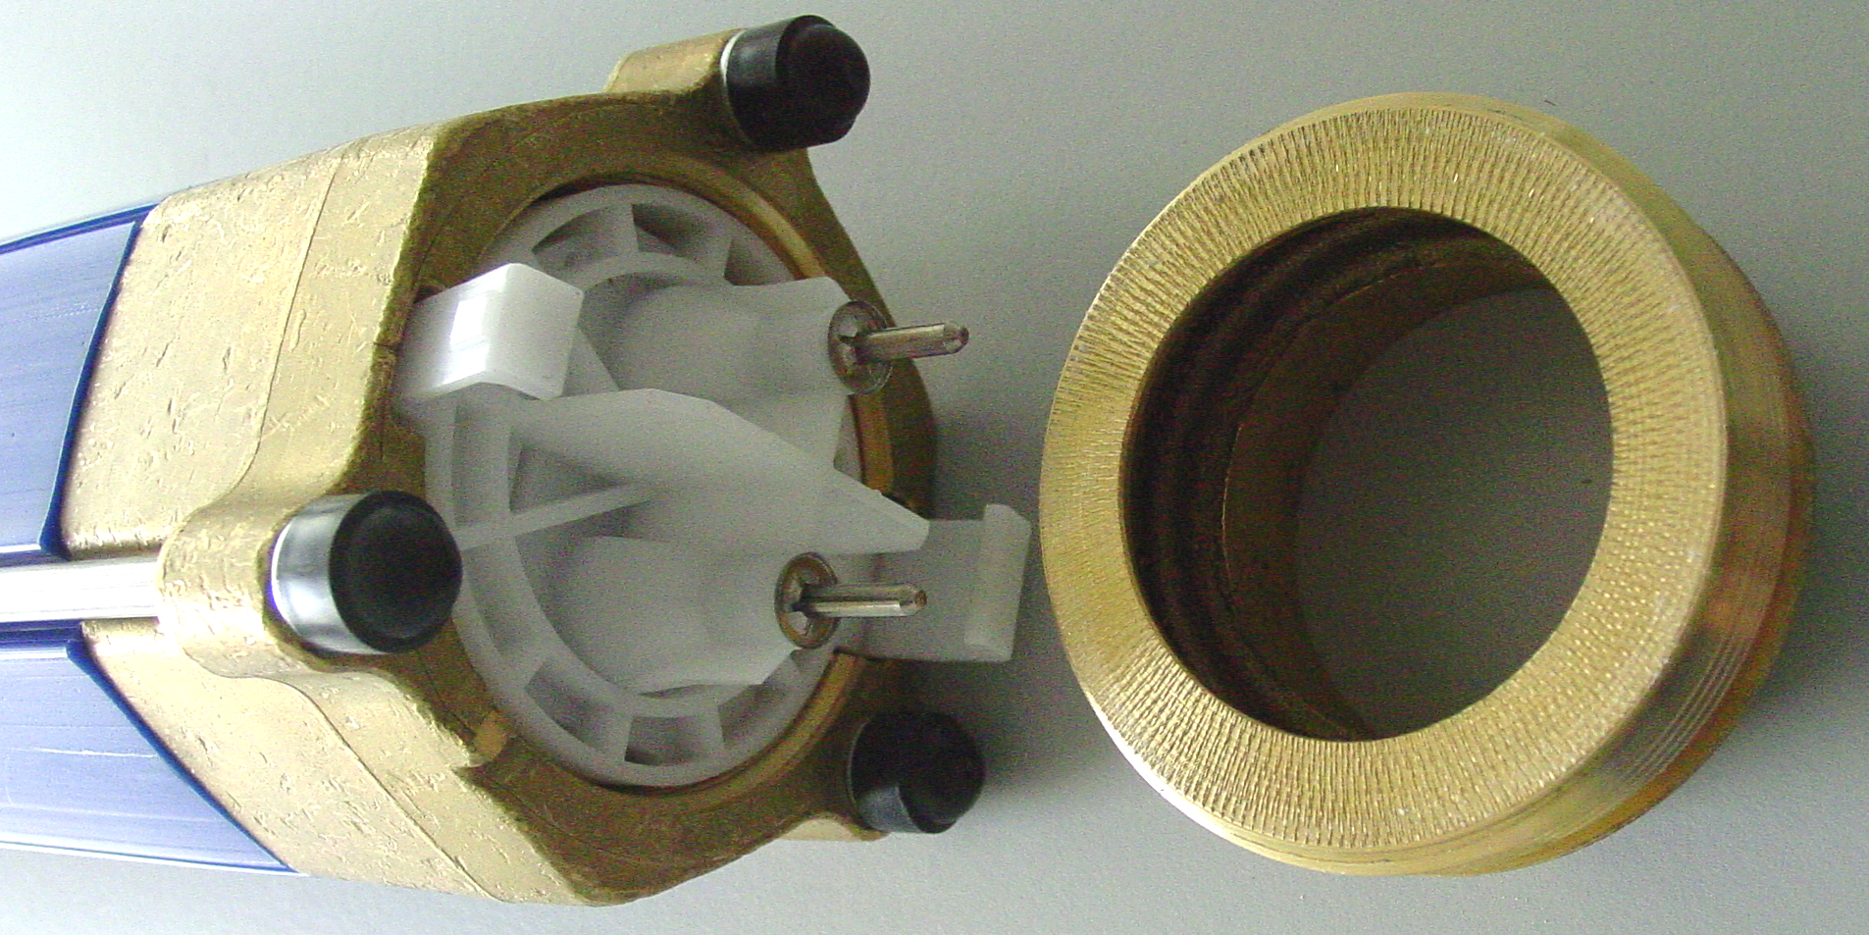
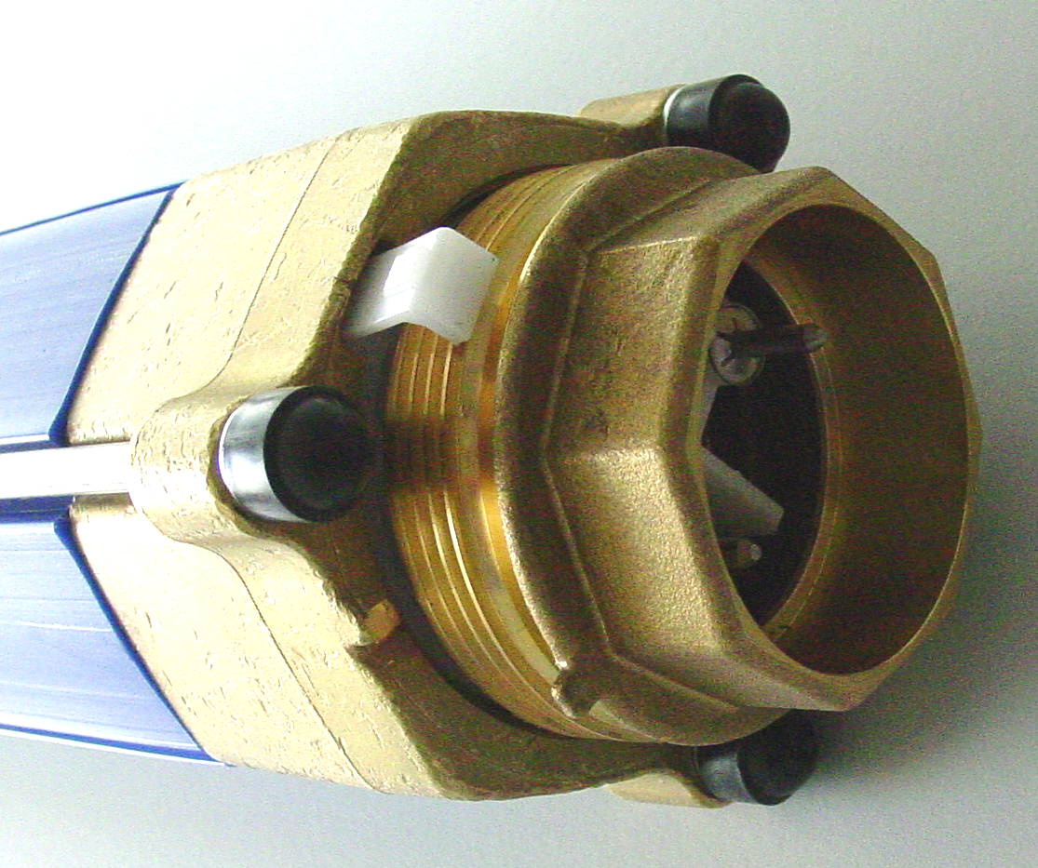
Change the device by
AQA-total cartridge new
(since cartridge Nr. 236000)
B. Installation
(mounting of the new device):

- Abandon the device from the flage.

- Put in the cup nut into the mounting link.

- Turn back the cup nut at the brass-flange with delivered 8-kant key.

- Turn the key clockwise.

- Tigthen up the cupnut til – the limit Stop of the flange.

- Jf is completed, please mount the cartrudge to the AQA-total.
7
8
5
4
6
9
CLOSE

